# Internet Applications Programming – Website Report

## Objective

I was tasked to develop a website for a restaurant of my choice, within this website it was a requirement to include a menu, shopping basket and administrator functions. From this objective I decided I could use the website I created earlier this year as a start point and develop new features from the basics given in this site.

Firstly I focused on website design, how the webpage should look throughout, I found the best method to do this using asp.net is design a master page and use this layout throughout the webpage as consistency.

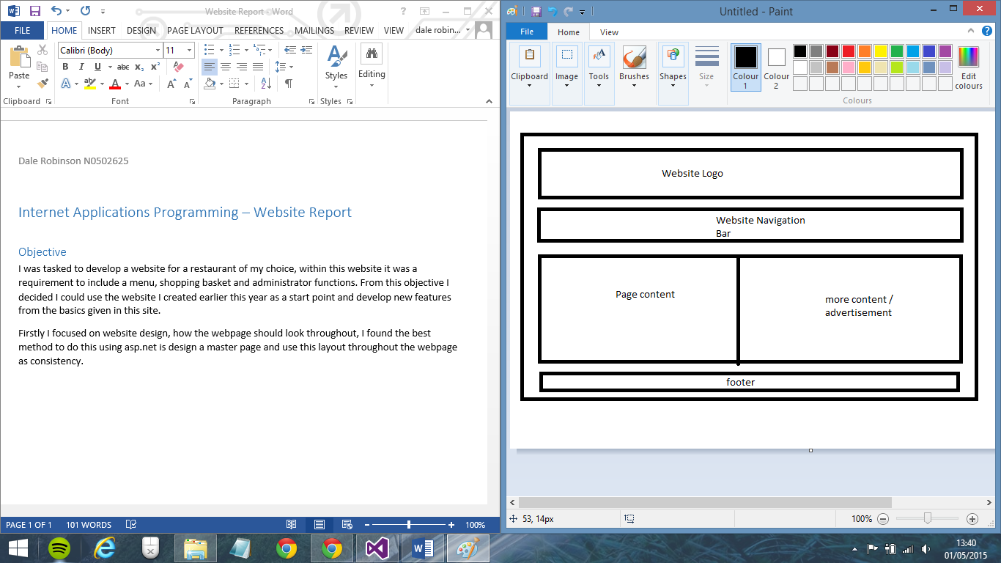Creating this master page also lead me onto creating the separate pages for my website. To comply with the specification I created webpages; Default(a page to log in or create an account, can also log in as admin),Home page, Order Page, Cart page, Menu and account options. Each of these pages also had their attached code behind file which allowed me to build functionality into these pages to allow for the user to interact when necessary eg. Clicking a button to add an item into their shopping cart.

## Pages

### Default Page

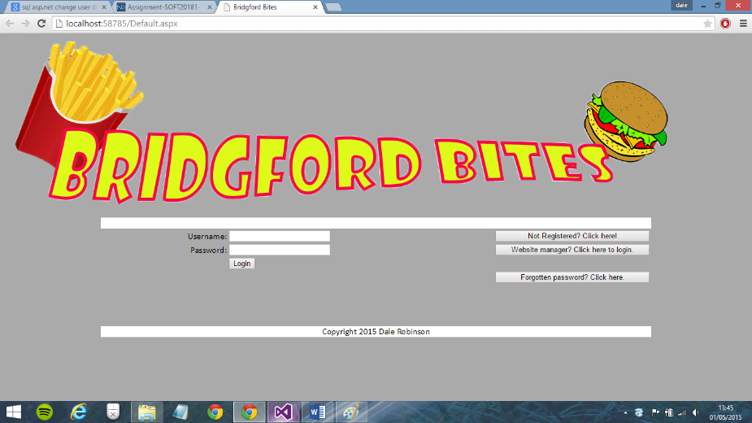This page is the first page a user sees if they are not logged in. This pages functionality includes a username and password login feature with validation checks and links to the create account and admin page. Should a user already exist they only have to enter their username and password. Validation from the login button will compare their input to the UserInformation database. Using compare statements the system will either take the user to the home page, or display that either their username or password does not match records within the database. Clicking the Not registered button will redirect the user to the create account page where the admin login will redirect the user to the admin page, however this will only happen should the username and password fields be filled in with the correct administrator information(username:admin, password:admin).

### Register Page

### 

When a user chooses to register an account they will be taken to the register page, from here text boxes will prompt the user to fill in username, email and password text boxes. When they have done this a unique idenfier will also be created for them using newGUID, this will create a random 128bit value which will be used in the primary key column userID. This identifier does not need to be known to the user however it is important to the database as to give each record a unique primary key. After registration the user is redirected to the home page where they can log in with the account they just created.

### Admin Page

This page is only available using the website manager button when both username and password fields are filled in with the username: admin and password:admin. From this page administrators are able to update and delete records from the user database and add or delete records from the products database. Logging in as a normal user will not grant you access to the admin page and it does not feature as a page in the navigation bar.

### Home and Our Menu Pages

These pages are used to make the website feel friendlier to the user, the home page features text about the restaurant and advertisement while the menu page shows the restaurants full menu in table form. These pages follow the design layout as set in the master page. The home page is the page the user is sent to after logging in on the default page.

### Order and Cart pages

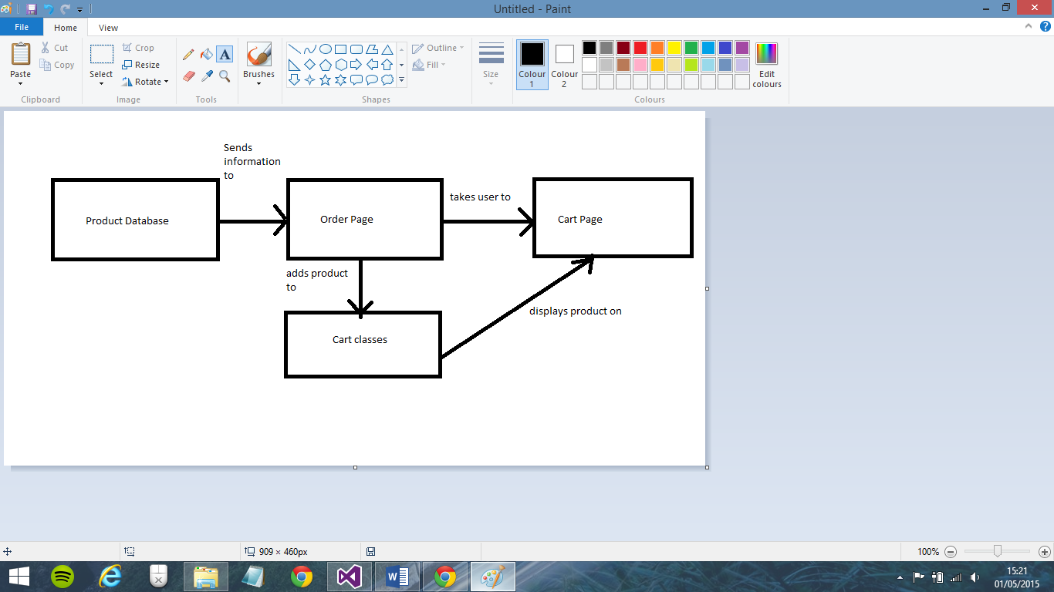These pages are used to allow a user to order products from the products database, this is done by creating an object cart with classes which allow it to store data on which record from the database is being selected for purchase along with the quantity of the purchase. On the order page the user is able to select any product from the product database via a dropdown box, once selected the user will be given information on the item and prompted to enter a quantity. The user is then able to go to the page checkout where they will be shown a list of all items they currently have in their cart. It is possible for the user to go back to the order page from the cart page to add more items to their basket. These are also updated in the text field on the cart page to display the user with all items in their cart. On the cart page information will be pulled from the database using an SQLDataSource function to fill in a grid, this grid will show all produce currently in stock.

### My Account

On this page the user will be greeted with their username, this is possible by storing their username as a session when they log into the site then calling the session to return the value for username. On this page the user can also view all their account information and can edit or delete their account, any edits made will be changed in the database and the user will be required to use their new log in details on their next log in attempt.

## Website functionality

1. Able to register an account, this will send information to the user database and store a record for each account. Primary key is a GUID which is automatically generated.
2. Able to log into an account to access the website, a user will need to log in to view the websites contents.
3. Able to log in as admin to change details, in this page website admins can change users information or delete records. It also allows for products to be added or deleted from the table.
4. Session is stored on login which remembers your login details while you are on the website, this allows for the website to be personalised to remember your login as well as make it possible for a user to update their details.
5. Shopping cart functionality, users are able to select products they wish to purchase and add them to a Cart. Cart can store multiple products.

## Challenges Encountered

1. Database was not correctly storing information when input from a page in the site, this was later fixed because the database was not saving to the correct location. I changed the database save location to be in the website folder which further information to be inserted into the table.
2. Unable to edit a record in a database. I was unable to do this as a primary key value was not assigned to each database, once I assigned a variable (userID or ProductID) I was able to edit records.
3. Admin page could only be implemented into the user website. To fix this if the username and password fields were filled with admin and you chose to log in as web administrator a new session would start under the name admin which would take the user to a page not normally accessible through the navigation on the site. This would allow for web administrators to edit details but normal users were unable to.
4. Unable for a user to search a record to add to their cart. To fix this problem the search function was replaced with a dropdown box which allows the user to select what product they wish to add to the cart.

## Testing

|  |  |  |  |  |
| --- | --- | --- | --- | --- |
| Test Number | Test Name | Test Description | Test Outcome | Changes |
| 1 | Login Invalid | Attempt to log into website with incorrect details | Validation errors are shown | N/A |
| 2 | Login Valid | Attempt to log into website with correct details | Taken to user information page. | Change the redirect to home page. |
| 3 | Create account | Register an account, check to login with the account. | Account created, able to login with account. Account is stored in database. | N/A |
| 4 | Login Admin | Log in to website administrator page with admin details | Able to log into admin webpage. | N/A |
| 5 | Admin edit details | Change the details of a customer, remove a customer, add new product, delete existing product. | Ran all functions all were able to interact with database and complete the query successfully. | N/A |
| 6 | User edit details | On the account page change the users details once logged in. | Changed username and password for user, was able to login with updated details. | N/A |
| 7 | Add to cart | On the stock page add products to the cart after this add multiple other products. | Products could be added to the cart. Products added to the cart are stored to a user. | N/A |

## Improvements

1. Update the cart to allow the total of the orders placed to be calculated, update the checkout page to give a form in which the user can enter their home and payment details what will send a message to the website owners alerting them that a user has made an order.
2. Update admin settings so that their can be multiple admin accounts which are in turn able to create more admin accounts, allow them more flexibility with data on products such as changing variables in existing products.
3. Add more detail to the my account page, this can include past orders on the site and storing further details such as house location and payment methods.